
Manual to use
MANUEL D'UTILISATION
BEDIENUNGSANLEITUNG
GEBRUIKSAANWIJZING
MANUAL DE USARIO
manuALE D’USO
KUBE
KB12
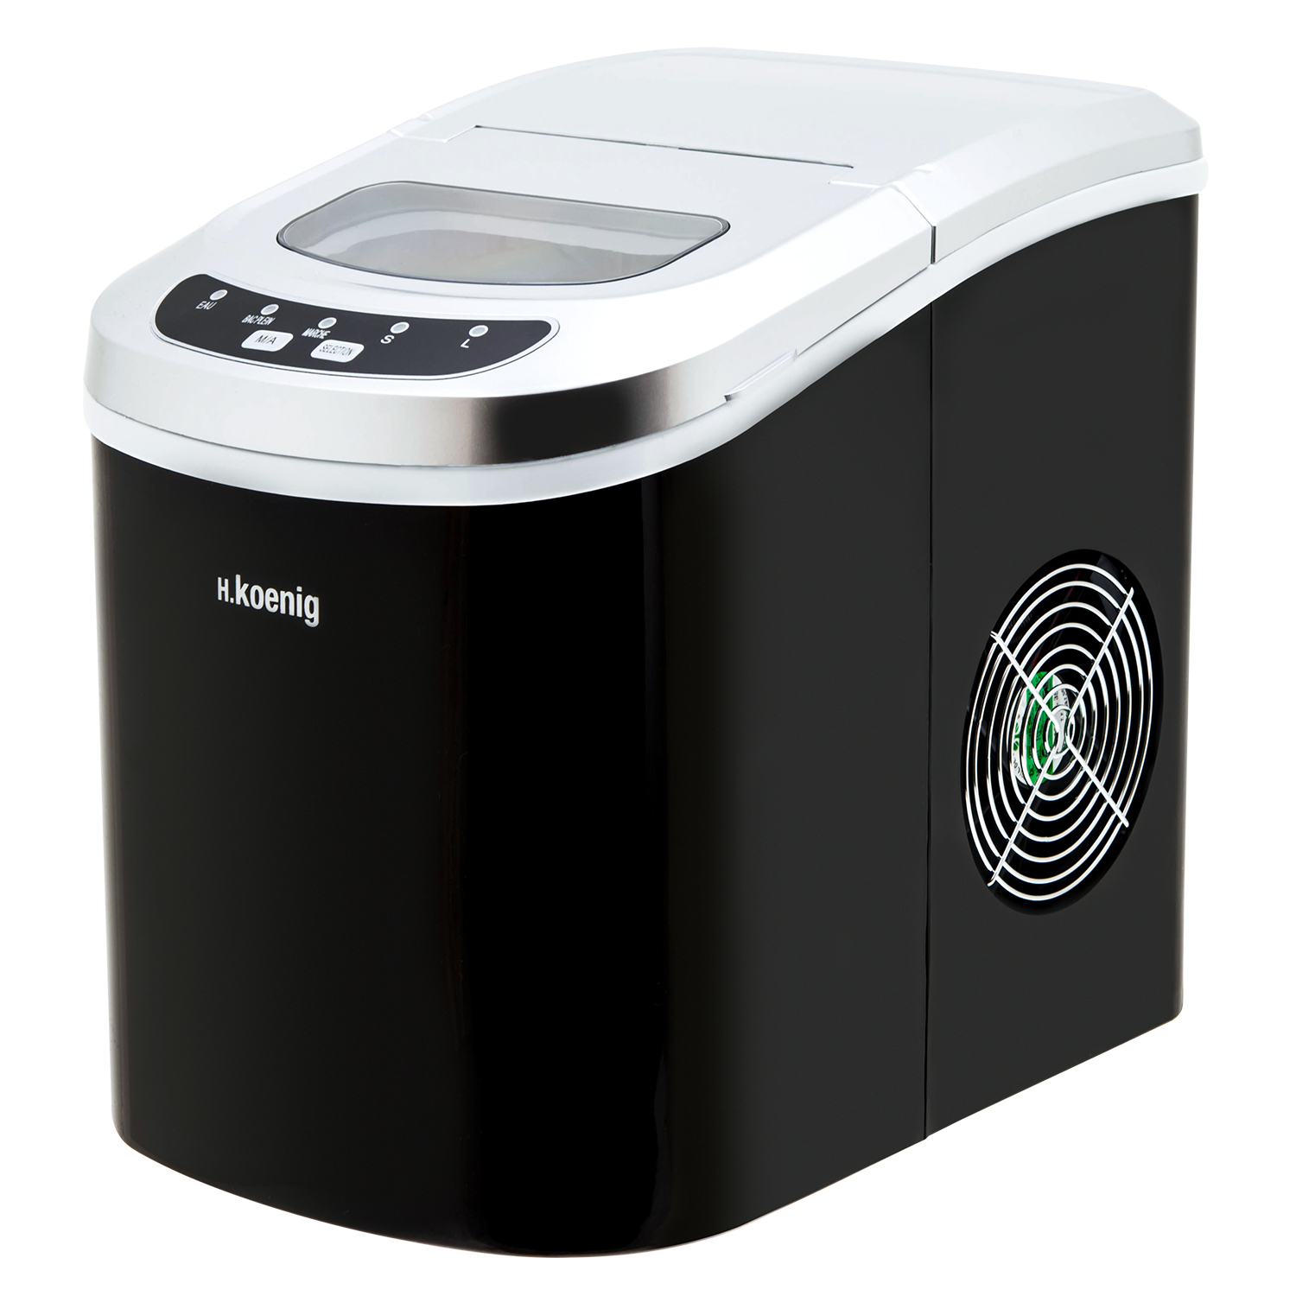
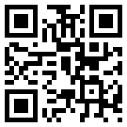
ice cream maker
machine à glAÇONS
EISMASCHINE
MÁQUINA DE HIELO
MACCHINA PER GHIACCIO
ENGLISH
INSTRUCTION MANUAL
It is important that you read these instructions before using your portable ice maker and we strongly recommend that you keep them in a safe place for future reference.

Your safety and the safety of others are very important.
TABLE OF CONTENTS
We have provided many important safety messages manual and your appliance.
Always read and obey all safety massages.
This is the safety alert symbol:
!
All safety messages will follow the safety alert symbol and the word “DANGER” or “WARNING”.

IMPORTANT SAFETY INSTRUCTIONS

DANGER
!

WARNING
!

These words mean:
You can be killed or seriously injured if you don’t immediate follow instructions.
All safety messages will tell you what the potential hazard is, tell you how to reduce the chance of injury, and tell you what can happen if the instructions are not followed.
When using electrical appliances, basic safety precautions should be followed to reduce the risk of fire, electric shock, and injury to persons or property. Read all instructions before using any appliance.
- Do not operate this，or any other appliance with a damaged cord.
If the supply cord is damaged, it must be replaced by the manufacturer or its service agent or a similarly qualified person in order to avoid a hazard.
This ice-maker must be positioned so that the plug is accessible .
Connect to properly polarized outlets only. No other appliance should be plugged into the same outlet. Be sure that the plug is fully inserted into the receptacle.
- Do not run the power cord over carpeting or other heat insulators. Do not cover the cord. Keep cord away from traffic areas, and do not submerge in water.
- We do not recommend the use of an extension cord, as it may overheat and become a risk of fire. If you must use an extension cord, use No. 0.75mm² minimum size and rated no less than 16A/250V~ with a plug.
- Unplug the ice maker before cleaning or making any repairs or servicing.
- Exercise caution and use reasonable supervision when appliance is used near children.
- Do not use your ice-maker outdoors. Place the ice-maker away from direct sunlight and make sure that there is at least 10mm of space between the back of your unit and wall. Keep a minimum distance of 10mm on each side of your unit free.
- Do not use other liquid to make the ice-cube other than water.
- Do not clean your ice maker with flammable fluids. The fumes can create a fire hazard or explosion.
- Do not tip over.
- If the ice maker is brought in from outside in wintertime, give it a few hours to warm up to room temperature before plugging it in.
- This appliance is not intended for use by persons (including children) with reduced physical, sensory or mental capabilities, or lack of experience and knowledge, unless they have been given supervision or instruction concerning use of the appliance by a person responsible for their safety.
- Children should be supervised to ensure that they do not play with the appliance.
● Please according to local regulations regarding disposal of the appliance for its flammable blowing gas. Before you scrap the appliance, please take off the doors to prevent children trapped.
WARNING: This appliance must be earthed.
IMPORTANT:
The wires in this mains lead are colored in accordance with the following code:
Green or Green with a strip yellow: Grounding
Blue: Neutral
Brown: Live
To avoid a hazard due to instability of the appliance, it must be placed at an even or flat surface.
- Do not store explosive substances such as aerosol cans with a flammable propellant in this appliance.
- This appliance is intended to be used in household and similar applications such as
- – staff kitchen areas in shops, offices and other working environments;
- – farm houses and by clients in hotels, motels and other residential type environments;
- bed and breakfast type environments;
- catering and similar non-retail applications.
- 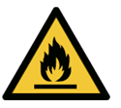 Warning: Risk of fire/flammable materials used. Please according to local regulations regarding disposal of the appliance for its flammable blowing gas. Before you scrap the appliance, please take off the doors to prevent children trapped.
- WARNING: Keep ventilation openings, in the appliance enclosure or in the built-in structure, clear of obstruction.
- WANING: Do not damage the refrigerant circuit.
- WARNING: Do not use mechanical devices or other means to accelerate the defrosting process or ice harvesting process, other than those recommended by the manufacturer.
- WARNING: Do not use other type of electrical appliances inside the ice-maker.
- This appliance must be earthed.
General instruction
1. Ice scoop.
2. Ice full sensor
GETTING TO KNOW YOUR UNIT
3. Ice basket
4. Top cover with transparent window
5. Air outlet
6. Water drain cap: at front btm side of the unit.
7. MAXIMUM WATER LEVEL: ▲
Remove the ice basket, you can see the water level mark.

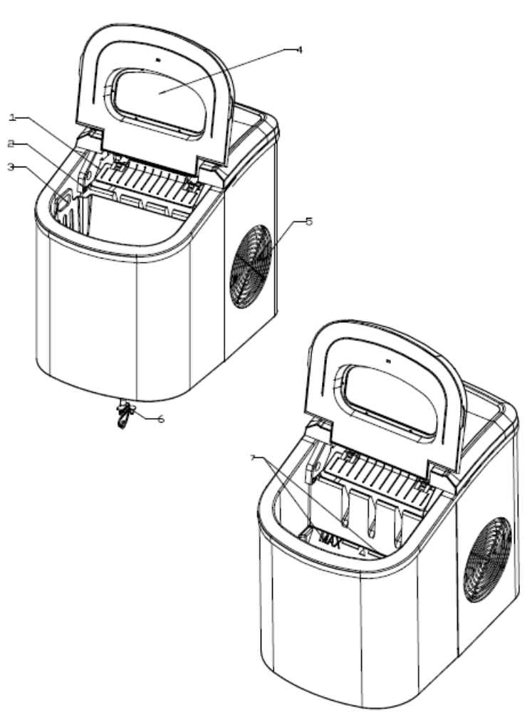

Position of control panel & function
Control Panel: Easy to use, visible functions touch display setting.
A. Selected ice size displaying: Small and Large.
B. Power indicator
C. Ice-Full indicator
OPERATING PROCEDURES & MAINTENANCE
D .Water shortage indicator
E. Button to turn on/off the unit.
F. Button to select ice cube size.

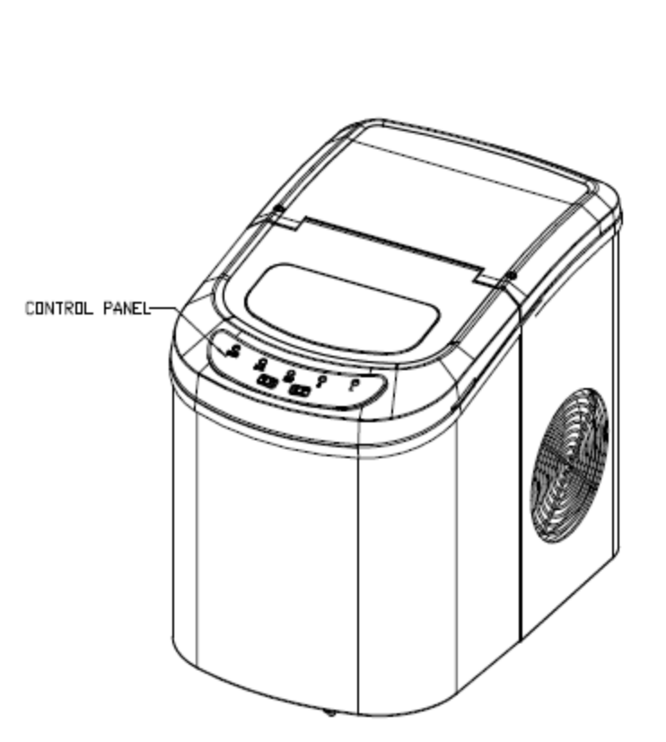

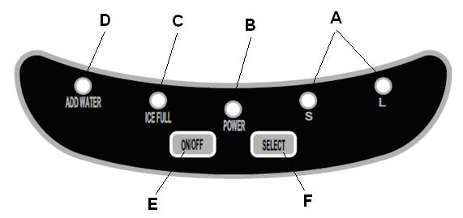

UNPACKING YOUR ICE MAKER
- Remove the exterior and interior packaging. Check if ice basket and ice scoop inside. If any parts are missing, please contact our customer service.
- Remove the tapes for fixing ice shovel, ice basket & ice scoop. Clean the tank & ice basket.
- Put the ice maker on a level & flat counter top without direct sunlight and other sources of heat (i.e.: stove, furnace, radiator). Maker sure that there is at least 10cm gap between the back & LH/RH sides with the wall.
- Allow one hour for the refrigerant fluid to settle before plugging the ice maker in.
- The appliance must be positioned so that the plug is accessible.
WARNING: fill with potable water only. Only use drinking water.
CONNECTING YOUR ICE MAKER
!
* Improper use of the grounded plug can result in the risk of electrical shock. If the power cord is damaged please call our customer service.

DANGER
- This unit should be properly grounded for your safety. The power cord of this appliance is equipped with a grounding plug which mates with standard grounding wall outlets to minimize the possibility of electric shock.
- Plug your appliance into an exclusive, properly installed, grounding wall outlet. Do not under any circumstances, damage the grounding means of the plug under any circumstances. Any questions concerning power and/or grounding should be directed toward a certified electrician.
- This appliance requires a standard 220-240Volt, 50Hz electrical outlet with good grounding means.

CLEANING AND MAINTAINING YOUR ICE MAKER
Before using your ice maker, it is strongly recommended to clean it thoroughly.
- Take out the ice basket.
- Clean the interior with diluted detergent, warm water and a soft cloth.
- Then use the water to rinse the inside parts, and drain out the water by unplugging the drain cap on front bottom side.
- The outside of the ice maker should be cleaned regularly with a mild detergent solution and warm water.
- Dry the interior and exterior with a clean soft cloth.
- When the machine is not to be used for a long time, drain water completely & dry the interior.

- Open the cover, remove the ice basket and pour water into tank.
Keep water level below the MAXIMUM water level mark.
USING YOUR ICE MAKER
- Press “ON/OFF” button on the control panel to begin the ice making cycle.
- Select the ice cube size by pressing the “SELECT” button. If the room temperature is lower than 15℃, it is recommended to select small ice cube in order to avoid ice sticking together.
- The ice making cycle lasts approx. 6 to 13 minutes, depending on seletion of ice cube size and the room temperature. The recommended room temperature is 10℃ to 43℃
- If water pump can’t inject water, the ice maker will stop automatically, and the “Add Water” indicator will be on.Press “ON/OFF” button, fill water up to the max. water level mark and press “ON/OFF” button again to turn on the unit again.Allow the refrigerant liquid inside the compressor at least 3 minutes to settle before restarting.
- The unit stops when the ice basket is full and the “Ice Full” indicator will be on. Warning: Direct sunlight or sunlight reflection may cause infared sensor malfunction. If the unit doesn’t stop even ice cubes obstruct sensor, move the unit where no sunlight.
- Change water in the water reservoir every 24 hours to ensure a reasonable hygiene level.
If unit isn’t to be used, drain all the water and dry the tank.

TROUBLESHOOTING
PROBLEM | POSSIBLE CAUSE | SOLUTION:
“Add Water” indicator is on. | Lack of Water. | Stop the ice maker, fill water, and press “ON/OFF” button again to restart the unit.
“Ice Full” indicator is on. | Ice is full in basket. | Remove ice from ice basket. Continuous press “Select” button 5 seconds, the unit could make ice 10 cycles even “Ice” indicator is on.
Ice cubes stick together. | The ice making cycle is too long. | Stop the ice maker, and restart it when the ice blocks melt. Select the small size ice cube selection.
Ice cubes stick together. | Water temperature in inner tank is too low. | Replace the water. Temperature of water recommended at 8-32℃
Ice making cycle is normal but no ice formed. | Room temperature or water temperature in inner tank is too high. | The room temperature should be 10-43℃, water temperature should be 8-32℃
Ice making cycle is normal but no ice formed. | Refrigerant in cooling system leaks. | Verify by a qualified technician.
Ice making cycle is normal but no ice formed. | Pipe in the cooling system is blocked. | Verify by a qualified technician.

Protection Type I I
Climate Type SN/N/ST/T SN/N/ST/T
Power 220-240V/50Hz 220-240V/50Hz
Ice Making Current 0.7A 0.7A
TECHNINCAL PARAMETERS
Ice Harvest Current 1.0A 1.0A
Refrigerant R600a/26g R600a/26g
Net Weight 8Kg 8kg
Vesicant C₅H₁₀ C₅H₁₀
Enclosure Plastic Stainless

Warranty Information
– WARNING: Keep ventilation openings, in the appliance enclosure or in the built-in structure, clear of obstruction.
– WARNING: Do not damage the refrigerant circuit.

The manufacturer provides warranty in accordance with the legislation of the customer's own country of residence, with a minimum of 1 year (Germany: 2 years), starting from the date on which the appliance is sold to the end user.
The warranty only covers defects in material or workmanship.
The repairs under warranty may only be carried out by an authorized service centre. When making a claim under the warranty, the original bill of purchase (with purchase date) must be submitted.
The warranty will not apply in cases of:
- Normal wear and tear
- Incorrect use, e.g. overloading of the appliance, use of non-approved accessories
- Use of force, damage caused by external influences
- Damage caused by non-observance of the user manual, e.g. connection to an unsuitable mains supply or non-compliance with the installation instructions
- Partially or completely dismantled appliances

ENVIRONMENT
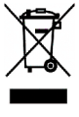
CAUTION :
Do not dispose of this product as it has with other household products. There is a separation of this waste product into communities, you will need to inform your local authorities about the places where you can return this product. In fact, electrical and electronic products contain hazardous substances that have harmful effects on the environment or human health and should be recycled. The symbol here indicates that electrical and electronic equipment should be chosen carefully, a wheeled waste container is marked with a cross.

Adeva SAS / H.Koenig Europe - 8 rue Marc Seguin, 77290 Mitry-Mory, France
www.hkoenig.com - sav@hkoenig.com - contact@hkoenig.com - Tél: +33 1 64 67 00 01

